Introduction to Photography
Final Exam: Website Portfolio
Due Tuesday June 13, 2017
C Period 7:30-9:30
B Period 9:50-11:50
Student Photo Website=80%
Presentation of Website=20%

- You will showcase 15-20 photos that you are most proud of from this class on your own website.
- The website must have a title page with your artist’s statement (see below for guidance), 1 page for your film/analog work, and 1 page for your digital work.
- At least 5 photos should be from film/pinhole. Film can be scanned into the computer.
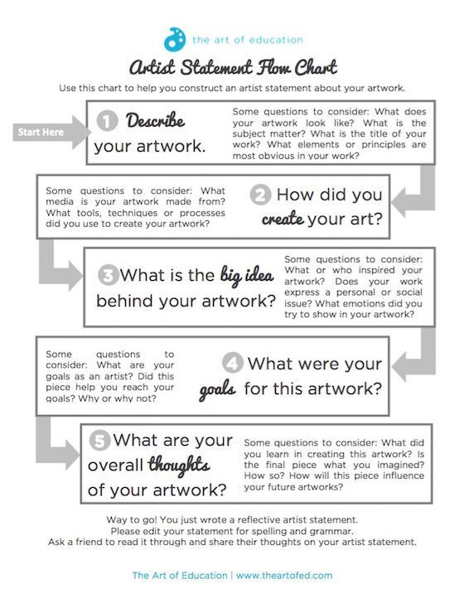
- You will present your website on the day of the exam. Your presentation should be between 5-7 minutes.
- To build your website you will use weebly.com.
- You will mostly create your website outside of class time, but will have one or two class periods to get it started and to scan any film. You must bring a flash drive to class to save any scanned film pictures, and digital images you will need for your site.

Criteria | Basic  (10 pts.) | Proficient  (15 pts.) | Advanced  (17 pts.) | Exemplary  (20 pts.)
The website contains a title page with artist’s statement, 1 page for film work, and 1 page for digital work. (total 3) | The website is incomplete or not submitted. | The website has fewer than 3 pages and artist statement offers minimal information. | The website has 3 or more pages yet the artist statement offers minimal information. | The website has three pages or more, and the artist’s statement offers abundant information.
The images are captioned or there is text with title information about each image. | Images are not captioned. | Some images are captioned. | Most images are captioned. | All images are captioned.
The website contains 15- 20 images by the student with at least 5 being from film. | The website contains less than 10 images. | The website contains less than 15 images. | The website contains 15-20 images, but less than 5 from film. | The website contains 15-20 images with at least 5 from film.
The student came to class prepared to work on his/her website will all images on a flash drive. | The student was unprepared while gathering images and had no flash drive. | The student did not use a flash drive to organize and store all images for their website. | The student used a flash drive to organize most of their pictures for the website. | The student used a flash drive and was always prepared in class to upload photos.
The presentation of the website is from 5-7 minutes, information is presented in a logical sequence, and student uses technical terminology. | The student does not present their website. | The presentation does not fall within the time limits, information in not organized into a logical order, student does not use technical terms. | The presentation does fall within the time limits, information is organized into a logical order, but student does not use technical terms. | The presentation does fall within time limits, information is organized into a logical order, and student used technical terms.
Total Points

Student Name_______________________________________ Period___________________

