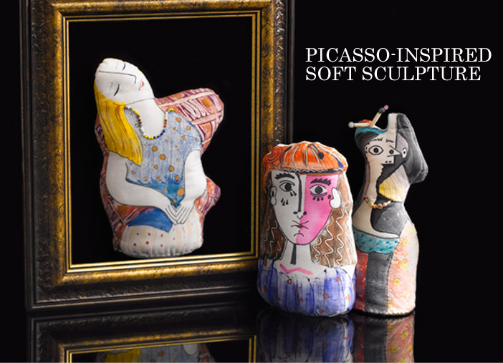
Abstract Figural
Soft Sculpture
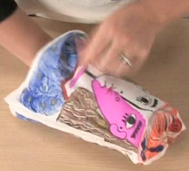
Cubism was a 20th century avant-garde art movement pioneered by Pablo Picasso and Georges Braque that revolutionized European painting and sculpture and inspired related movements in music, literature, and architecture. Picasso demonstrated uncanny artistic talent in his early years, painting in a realistic manner throughout his childhood and adolescence; during the first decade of the 20th century his style changed often as he experimented with different ideas and theories. Picasso is known for his blue and rose periods, his African-influenced period, and for various types of cubism. Picasso was most well-known for his paintings, but he was also a sculptor.

In this project, we have a chance to produce reinterpretations of the works of Picasso and other abstract artists! The simplified forms of cubism lend themselves beautifully to soft sculpture reproductions. By looking through the vast array of figurative paintings done by Picasso during his cubist phase, we find many possibilities for soft sculpture adaptations. Fine art, sculpture, and textiles combine to make an eye-catching piece.

- Use the following websites to research the artwork by 3 of the following contemporary 20th century artists. Find a figural painting (a painting of a person).
- Pablo Picasso
- Kasimir Malevich
- Paul Klee
- Agnes Martin
- Henri Matisse
- Franz Marc
- Roy Lichtenstein
- Frank Stella

https://www.artsy.net
http://www.artcyclopedia.com/

- Create a 5 page word document with the first page as a title page with your name, and copy and paste one picture/example for each artist onto each page. Under each example, caption the image with the artist name and the title of the work. Choose three words to describe your interpretation about the painting (Example- Peaceful, Subdued, Dreamlike)

- Choose one artist’s style (1 painting) to use as a foundation for your soft sculpture.

- On the last page, critique the artwork of choice using the 4 parts of art criticism (Describe, Analyze, Interpret, Judge) Paste the image into the last page with the caption and use shapes to make a callout and write a brief description of that artist’s paintings (colors used, lines, shapes), analyze the art (Determine the essential elements or features), interpret their work (What does the work mean?), and judge the artwork (What makes it successful?)

- Draw a few sketches (back and front) of what you want your soft sculpture to look like. (You are not copying the painting, just using elements of the artist’s style)

- Submit the research with art criticism, and keep your sketches to start making your pattern.

Example of last page art criticism
Description-The colors mainly consist of the primary colors red, yellow and blue, with small areas of green. The value of the colors shows a gradual change from light to dark which emphasize the roundness of the horses bodies.
Interpretation- I think this painting is about a period of rest. The position of the horses shows that they are standing and grooming themselves after a run. The simplicity of the painting combined with the limited color palette creates a calm feeling.

Analysis- The repetition of the curves creates a visual rhythm and evokes a relaxing composition.

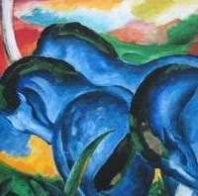
Description- The shapes are organic, and lines and curves flow into each other.
Judgement- I like this painting because it is simple, calming, and horses are my favorite animal.
Figure 1 Franz Marc, The Large Blue Horses, 1911

